**[ 2CEIT5PE5: MOBILE APPLICATION DEVELOPMENT]**

Practical: 8



**AIM- What is Frame by Frame Animation? What is Twin Animation? How can you achieve edge-to-edge content display in your app? Create Android Application to demonstrate Frame by frame animation and splash screen to demonstrate twin animation according to below instructions.**

Submitted By: Dhruv.S.Lakhani Enrollment number: 20012011055



# Department of Computer Engineering/Information Technology

**Practical-8**

**AIM:- What is Frame by Frame Animation? What is Twin Animation? How can you achieve edge-to-edge content display in your app? Create Android Application to demonstrate Frame by frame animation and splash screen to demonstrate twin animation according to below instructions.**

# Activity_main.xml:-

# <?xml version="1.0" encoding="utf-8"?> <androidx.constraintlayout.widget.ConstraintLayout xmlns:android="http://schemas.android.com/apk/res/android" xmlns:app="http://schemas.android.com/apk/res-auto" xmlns:tools="http://schemas.android.com/tools" android:layout_width="match_parent" android:layout_height="match_parent" tools:context=".MainActivity"> <LinearLayout android:layout_width="match_parent" android:layout_height="match_parent" android:orientation="vertical" app:layout_constraintStart_toStartOf="parent" app:layout_constraintEnd_toEndOf="parent" app:layout_constraintTop_toTopOf="parent" app:layout_constraintBottom_toBottomOf="parent"> <androidx.core.widget.NestedScrollView android:layout_width="match_parent" android:layout_height="match_parent"> <com.google.android.material.card.MaterialCardView android:layout_width="match_parent" android:layout_height="wrap_content" android:layout_marginTop="15dp" android:layout_marginBottom="15dp" android:layout_marginStart="10dp" android:layout_marginEnd="10dp" app:cardCornerRadius="7dp" app:cardElevation="7dp"> <LinearLayout android:layout_width="match_parent" android:layout_height="match_parent" android:orientation="vertical"> <ImageView android:id="@+id/alarmImages" android:layout_width="match_parent" android:layout_height="742px" /> <TextView android:layout_width="match_parent" android:layout_height="wrap_content" android:text="Create Alarm Time" android:textSize="17sp" android:textStyle="bold" android:layout_marginTop="10dp" android:layout_marginStart="10dp"/> <TextView android:layout_width="match_parent" android:layout_height="wrap_content" android:text="@string/alarm_desc" android:layout_marginTop="10dp" android:paddingEnd="10dp" android:layout_marginStart="10dp"/> <TextView android:layout_width="match_parent" android:layout_height="wrap_content" android:text="@string/check_curTime" android:layout_marginTop="10dp" android:paddingEnd="10dp" android:layout_marginStart="10dp"/> <ImageView android:id="@+id/heartImages" android:layout_width="27dp" android:layout_height="27dp" android:layout_marginTop="2dp" android:layout_marginEnd="25dp" android:layout_gravity="right" /> <LinearLayout android:layout_width="wrap_content" android:layout_height="wrap_content" android:orientation="horizontal" android:layout_marginStart="10dp" android:layout_marginTop="15dp" android:layout_marginBottom="10dp"> <com.google.android.material.button.MaterialButton android:layout_width="wrap_content" android:layout_height="wrap_content" app:cornerRadius="20sp" android:text="Create Alarm" android:textSize="10sp" app:icon="@drawable/ic_baseline_alarm_add_24" app:iconSize="20sp" android:backgroundTint="@color/teal_200"/> <com.google.android.material.button.MaterialButton android:layout_width="wrap_content" android:layout_height="wrap_content" android:layout_marginStart="7dp" app:cornerRadius="20sp" android:text="Create Alarm" android:textSize="10sp" app:icon="@drawable/ic_baseline_alarm_off_24" app:iconSize="20sp" android:textColor="@color/teal_200" android:backgroundTint="@color/white" app:iconTint="@color/teal_200"/> </LinearLayout> </LinearLayout> </com.google.android.material.card.MaterialCardView> </androidx.core.widget.NestedScrollView> </LinearLayout> </androidx.constraintlayout.widget.ConstraintLayout>

# activity_Splash.xml:-

# <?xml version="1.0" encoding="utf-8"?> <FrameLayout xmlns:android="http://schemas.android.com/apk/res/android" xmlns:app="http://schemas.android.com/apk/res-auto" xmlns:tools="http://schemas.android.com/tools" android:layout_width="match_parent" android:layout_height="match_parent" tools:context=".SplashActiviy" android:background="@drawable/gradientrectangle"> <ImageView android:id="@+id/image" android:layout_width="wrap_content" android:layout_height="120dp" android:layout_gravity="center"/> </FrameLayout>

**MainActivity.kt:-**

package com.example.madpractical8_20012011055  
  
import android.graphics.drawable.AnimationDrawable  
import androidx.appcompat.app.AppCompatActivity  
import android.os.Bundle  
import android.view.animation.Animation  
import android.view.animation.AnimationUtils  
import android.widget.ImageView  
  
class MainActivity : AppCompatActivity(), Animation.AnimationListener {  
 lateinit var alarmimgs : ImageView  
 lateinit var alarmimg_frameByFrameAnimation : AnimationDrawable  
 lateinit var alarmimgAnimation : Animation  
 lateinit var heartimgs : ImageView  
 lateinit var heart_frameByFrameAnimation : AnimationDrawable  
 lateinit var heartAnimation : Animation  
 override fun onCreate(savedInstanceState: Bundle?) {  
 super.onCreate(savedInstanceState)  
 setContentView(R.layout.activity_main)  
 alarmimgs = findViewById(R.id.alarmImages)  
 alarmimgs.setBackgroundResource(R.drawable.alarm_image_list)  
 heartimgs = findViewById(R.id.heartImages)  
 heartimgs.setBackgroundResource(R.drawable.heart_image_list)  
 alarmimg_frameByFrameAnimation = alarmimgs.background as AnimationDrawable  
 heart_frameByFrameAnimation = heartimgs.background as AnimationDrawable  
 alarmimgAnimation = AnimationUtils.loadAnimation(this, R.anim.alarm_animation)  
 alarmimgAnimation.setAnimationListener(this)  
 heartAnimation = AnimationUtils.loadAnimation(this, R.anim.heart_animation)  
 alarmimgAnimation.setAnimationListener(this)  
 }  
 override fun onWindowFocusChanged(hasFocus: Boolean) {  
 super.onWindowFocusChanged(hasFocus)  
 if(hasFocus){  
 alarmimg_frameByFrameAnimation.start()  
 alarmimgs.startAnimation(alarmimgAnimation)  
 heart_frameByFrameAnimation.start()  
 heartimgs.startAnimation(heartAnimation)  
 }  
 }  
 override fun onAnimationStart(p0: Animation?) {  
 }  
 override fun onAnimationEnd(p0: Animation?) {  
 }  
 override fun onAnimationRepeat(p0: Animation?) {  
 }  
}

# SplashActivity.kt:-

package com.example.madpractical8_20012011055  
  
import android.content.Intent  
import android.graphics.drawable.AnimationDrawable  
import androidx.appcompat.app.AppCompatActivity  
import android.os.Bundle  
import android.view.animation.Animation  
import android.view.animation.AnimationUtils  
import android.widget.ImageView  
  
class SplashActiviy : AppCompatActivity(),Animation.AnimationListener {  
 lateinit var guni_image : ImageView  
 lateinit var logo_frambyframanimetion : AnimationDrawable  
 lateinit var twinanimetion : Animation  
 override fun onCreate(savedInstanceState: Bundle?) {  
 super.onCreate(savedInstanceState)  
 setContentView(R.layout.*activity_splash*)  
 guni_image = findViewById(R.id.*image*)  
 guni_image.setBackgroundResource(R.drawable.*uvpce_logo_list*)  
 logo_frambyframanimetion = guni_image.*background* as AnimationDrawable  
 twinanimetion = AnimationUtils.loadAnimation(this,R.anim.*twin_animation*)  
 twinanimetion.setAnimationListener(this)  
 }  
 override fun onWindowFocusChanged(hasFocus: Boolean) {  
 super.onWindowFocusChanged(hasFocus)  
 if (hasFocus){  
 logo_frambyframanimetion.start()  
 guni_image.startAnimation(twinanimetion)  
 }  
 }  
 override fun onAnimationStart(p0: Animation?) {  
 }  
 override fun onAnimationEnd(p0: Animation?) {  
 Intent(this,MainActivity::class.*java*).*also* **{** startActivity(**it**)  
 overridePendingTransition(R.anim.*scale_center_in*,R.anim.*scale_center_out*)  
 finish()  
 }  
}  
 override fun onAnimationRepeat(p0: Animation?) {  
 }  
}

**Output:-**

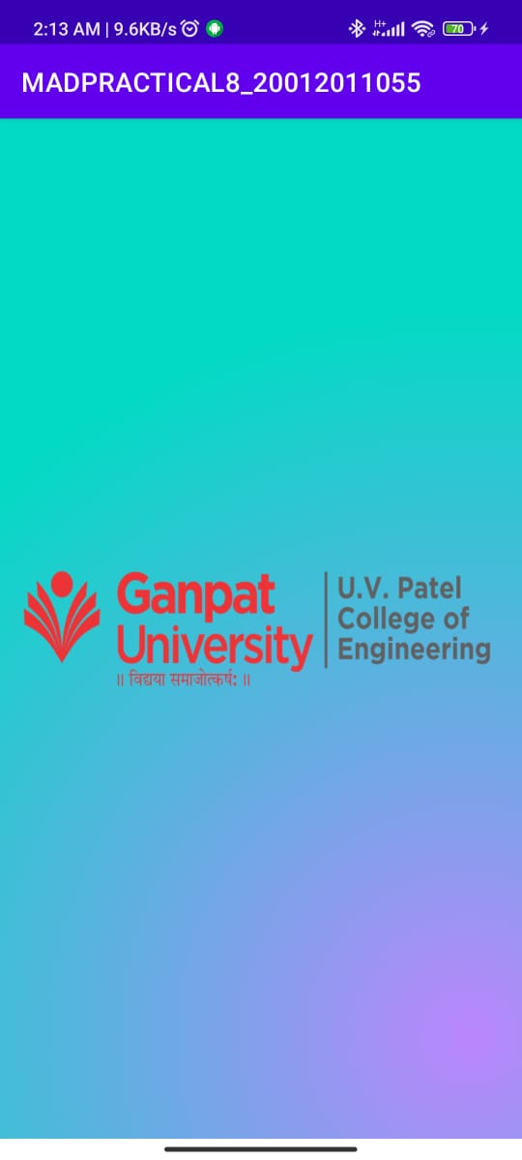 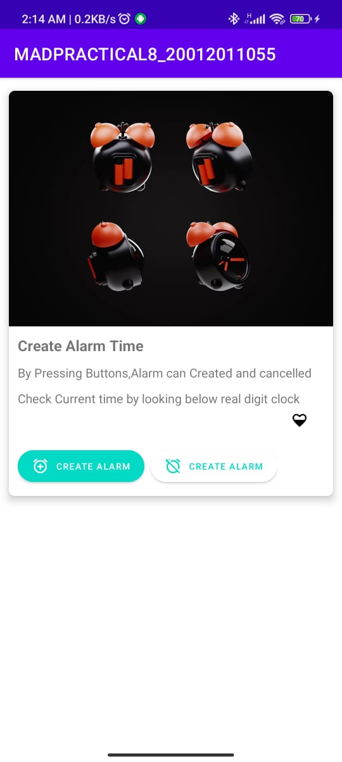

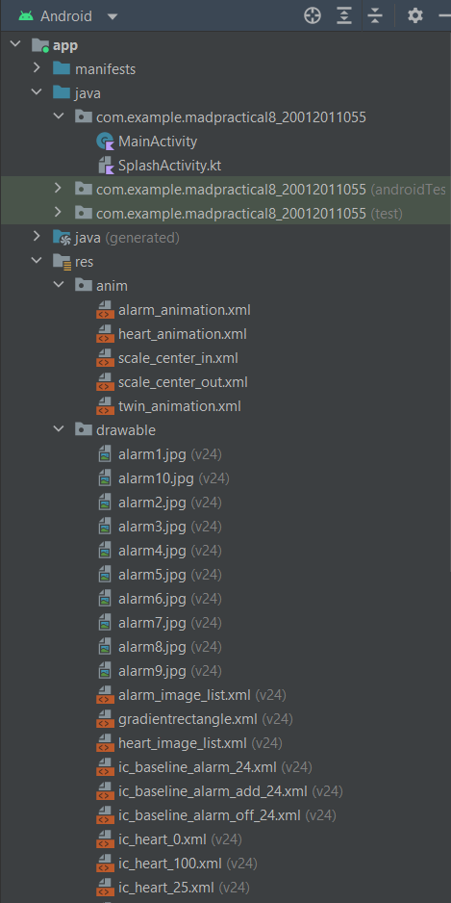 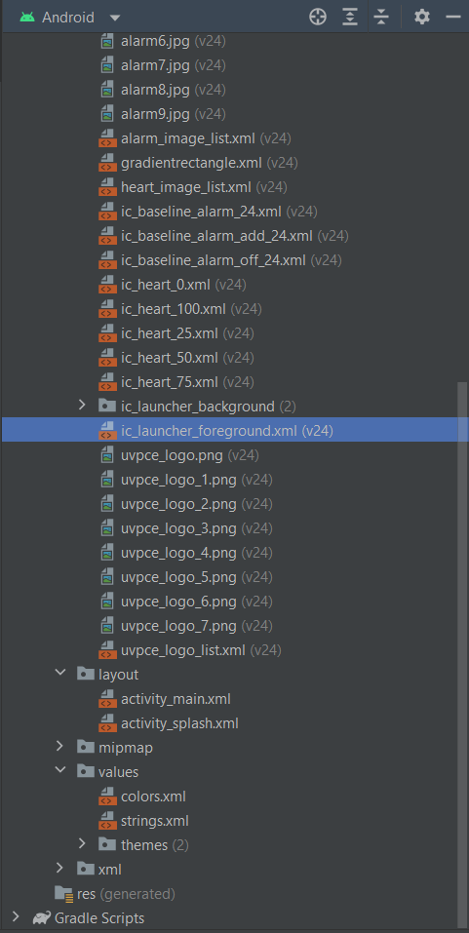

# AndroidManifests.xml

<?xml version="1.0" encoding="utf-8"?>  
<manifest xmlns:android="http://schemas.android.com/apk/res/android"  
 xmlns:tools="http://schemas.android.com/tools"  
 package="com.example.madpractical8_20012011055">  
  
 <application  
 android:allowBackup="true"  
 android:dataExtractionRules="@xml/data_extraction_rules"  
 android:fullBackupContent="@xml/backup_rules"  
 android:icon="@mipmap/ic_launcher"  
 android:label="@string/app_name"  
 android:roundIcon="@mipmap/ic_launcher_round"  
 android:supportsRtl="true"  
 android:theme="@style/Theme.MADPRACTICAL8_20012011055"  
 tools:targetApi="31">  
 <activity  
 android:name="com.example.madpractical8_20012011055.MainActivity"  
 android:exported="false" />  
 <activity  
 android:name=".SplashActiviy"  
 android:exported="true">  
 <intent-filter>  
 <action android:name="android.intent.action.MAIN" />  
  
 <category android:name="android.intent.category.LAUNCHER" />  
 </intent-filter>  
 </activity>  
 </application>  
  
</manifest>